**MoodRay**

**The MoodRay Lamp**

“Light the Mood, Feel the Music” – a brand slogan that connects light, music, and emotion.

Overview

Colour- associated with mood (psychological studies related to mood and colour).

Music- associated with mood (psychological studies related to mood and music- specifically how certain music IMPROVES mood and how the type of music you listen to affects your mood).

Shows the importance of both colour and music on human mood.

Audience

* Teenagers and young adults
* Tend to face mental health problems on a daily basis such as stress, anxiety, mood swings.
* Music plays an important role in the lives of both- said to be a hobby (find studies to show that majority of people listen to music on a daily basis- how it has a significant improvement to mood).
* Related to mental health (studies that show the importance of mental health in teens and young adults in this day and age)- market is large.

Gap in the market

* Products exist however do not improve mood but rather keeps the mood the same.
* No products exists that consists of both colour and music interlinked to enhance or detect mood.

Why is the product appropriate?/ why we chose this product?

* Role of technology and AI- technology and AI play a huge role in todays world (find studies to support how tech and AI is used in almost everything and the importance of it in the world specifically relating to mood/colour/music- how is technology and AI important in enhancing mood relating to colour and music etc).
* Importance of mental health- the importance of mental health in todays world and how music and colour are aspects to improving mood which is related to improving mental health as well- find studies to show that mood is linked to mental health, hence enhancing mood can improve mental health on a small or large scale).

Main features

* Mental health and mood enhancement
* Smart home/IoT devices
* Customization and DIY
* Music-based therapy
* Aesthetic room décor

Suggestions to Improve or Differentiate Further:

Voice Assistant Integration (e.g., Alexa or Google Assistant)

Ambient Sound Detection: Adjusts to the environment, not just user mood.

Sleep/Wake Modes: Light + music combo for sleep or morning routines.

Features You Could Highlight or Develop:

A mood calendar in the app, tracking emotional trends over time

Ambient sound recognition (e.g., soothing tones when loud or stressful sounds are detected)

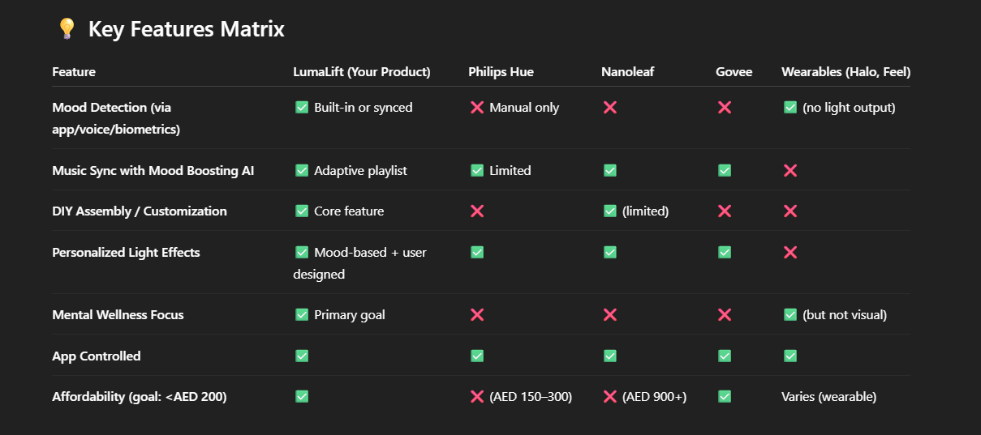

Features of the product

* Speaker
* Voice recognition software
* Touch based
* Surrounding light (maximum ability to light up the whole room or just a concise area like desk).
* Portable and compact
* Rechargeable batteries (sustainable element)
* Variety of colours
* Auto dimming at night

Features of the app

* Integrated to music applications- spotify, apple music etc
* Integrated to home systems- alexa, apple home, google
* Payment plan included in the app itself

How to operate/ how it works

* Ability to insert mood and accordingly the music will play, and colour of the lamp will detect the mood and change
* Start playing the music based on your mood and it will change the colour and music progressively making your mood better
* Can turn the speaker on verbally, physically, or through the app (verbal physical or manual commands).
* Can verbally tell your mood to the speaker and it will turn the lamp on and display the colour as well as play music to enhance mood (customers do not have to physically queue or start playing music or lighten the room).

USP/competitive advantage

* Product is accessed through an application
* Require paying to access the exclusive features
* ability to change mood while listening to music (something everyone enjoys doing-supported by evidence/stats)
* enables customer loyalty as it is a premium product/service which competitors cannot offer
* gains competitive advantage as customers do not have to physically queue or start playing music or lighten the room to improve their mood (convenient and easy access).

SWOT and PESTLE

Strengths/ opportunities

* Emotional Benefit: Ties into the growing awareness and demand for mental well-being tools.
* Tech Integration: Linking with an app allows dynamic features like mood tracking, personalization, and syncing with other smart devices.
* Cross-Sensory Experience: Combining light and music enhances engagement and perceived impact.
* Competitors do not have similar systems which is linked and controlled through an app.

Weaknesses/ threats

* does not have the aesthetic element like competitor nanoleaf
* bugs and privacy concerns while using the app
* reasonably expensive but not budget friendly like competitor govee lights
* high production costs
* similar products (light-based lamp relating to mood) exist in the market with high market value and large numbers of customers

will be improved overtime depending on profits (aim to work and eliminate our weaknesses overtime).